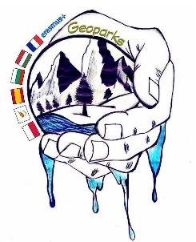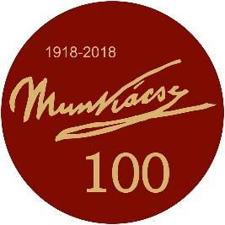

PROGRAMME 4th Training of Students
Kaposvár, Hungary
“Geoparks – Natural and Cultural Heritage that joins European Students and Teachers” 2018-1-PL01-KA229-050575_5
30.09.2019 – 04.10.2019
Organized by Kaposvári Munkácsy Mihály Gimnázium (7400 Kaposvár Kossuth Lajos utca 48.)
MONDAY  30.09.2019 | TUESDAY  01.10.2019 | WEDNESDAY  02.10.2019 | THURSDAY  03.10.2019 | FRIDAY  04.10.2019
Arrival of delegations*  Our Erasmus Plus partners (teachers and students) arrive at Budapest airport in Hungary. Transfer to the hotel in Kaposvár.  Host families will wait for the students at the hotel, depending on the time of their arrival. | 08:30  Teachers: Welcome of the Director of the Kaposvári Munkacsy Mihály Gimnázium to the European team of professors.  Presentation of the team and the project by the European coordinator Magdalena Szewczyk (Poland).  Students: Attend normal classes with the host students. | GEOPARK OF BAKONY – BALATON  Students: breakfast, picnic lunch and dinner offered by the host family  Teachers breakfast - packed breakfast from the Hotel, lunch –during the free time (at their own charge) | 08:30 – 10:00  STUDENTS: ICT classroom to preapare their posters on the topic “ Geoparks and tourism”  mixed teams (using own photos)  TEACHERS: teachers’ meeting | Departure of delegations*
 | 10.30 – 11.00 Break (coffee and snacks) | Trip to major sites of the Bakony-Balaton Geopark  6:30  Kaposvár - Szántód – Szentbékkálla – Monoszló – Tihany - Kaposvár  The rocky ridge of Szentbékkálla - short field trip (walk)  Hegyestű Geological Interpretive Site, Monoszló  Visit to Tihany Abbey | 10.00 – 10.30: Break (coffee and snacks)
 | 11:00 – 12:30  School Presentations of Georparks on the topic of -  “ Geoparks and tourism”  (10 min each) |  | 10:30 – 11:30  Presentation of the posters.  Project Certificates ceremony.
 | 12: 30 – 13:30 Lunch  Teachers: Lunch at school that will be offered by Hungarian team  Students will go to host families for lunch | 13:00 – 14:30 Lunch and freetime activities | 11. 30 –  Trip to the village museum in Szenna  Craft workshop with the students “Experience the traditions”  Lunch inthe village museum for all
 | 13:30 – 14:30  Interactive sightseeing – mixed teams | 14:30 – 16: 30  Lóczy Lajos Nature Trail, Tihany - short field trip (walk) in the peninsula | 16:00  Trip to the Observatory in Kardosfa
 | 14:30 – 17.30  Free time till the evening | 16:30 Departure from Tihany to Kaposvár | 19.30  Farewell party in Bőszénfa Restaurant – traditional Hungarian game dishes
 | 18:00 – 21:00  Hungarian Night at the school.  Teachers of the Hungarian team, Students will prepare and offer a night with traditional food, sweets, drinks, dances and music from Hungary.  Participating students will come with host families and teachers from the hotel. | 19:00 –  Free evening  Dinner teachers in Kaposvár  (at their own charge) | 22.00 Departure from Bőszénfa to Kaposvár

*See additional file for exact arrival and departure dates and times
http://www.kaposhotel.hu/
http://www.tourinformkaposvar.hu/index.php?p=0&lang=en
http://www.mmgsz.sulinet.hu/
http://www.bfnp.hu/en/
http://www.geopark.hu/en/
https://www.bfnp.hu/en/kali-basin
http://www.bfnp.hu/en/hegyestu-geological-visitor-site-monoszlo
http://www.tihanyiapatsag.hu/Programok_turizmus.html
http://szennai.skanzen.hu/en
http://zselicicsillagpark.hu/en.php

