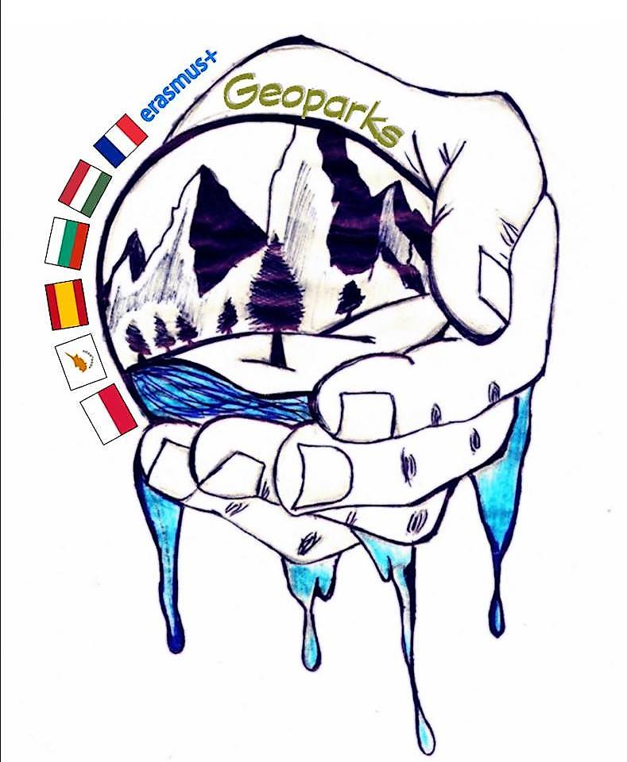

REPORT OF COORDINATOR

term 1 2018/2019

school name | LPO POINTE NOIRE
coordinator | SUBIRATS Nathalie

number of teachers involved in project | 6
number of students involved in project | 11

Project Event Details (according to mobility tool)

Please list and describe all project activities other international meeting for example: project management meetings, dissemination activities and other local activities and events in each school. The activities listed here will be included in the partnership final report as part of the project timetable.

Type of activity | start date | end date | short description
ERASMUS CORNER | September | September | Internet research on each country of the project and panel presentation at the library. Use of digital tools, research in autonomy, collaboration between students, selection of information.  Research on the label "Geopark" and "National Park".  Geographic location of countries, Geopark, cities and high school partners. More general research on the country and its inhabitants. Realization of poster board presenting different aspects of each country (politics, history, geography, nature and culture).Make the project known to the school community and keep them informed of the steps.
Preparatory tasks mobility Cyprus | September | october | Presentation of the French overseas territory of Guadeloupe in its natural geographical and natural historical singularity.  Making of a film of the school and its environment with and by the students
Post-mobility tasks in Cyprus: | november | September | Issues of a mobility: interest, expected reslts and unexpected events ... By the lens and the experience of the participants.
Logos contest | december | december | Give the visual identity to the project. Allow the participants to appropriate the subject developed in the project by preparatory research on the Geoparks. Develop co-operation and emulation between students. build a representative synthetic image of the project.
Contest make your own GEOPARK | January | April | Making of the imagery and writing of the rules. : imagined by the students of the project for the junior schools of the Côte-sous-le-vent. Production and difusion of a digital poster with the contest rules to the junior schools.

