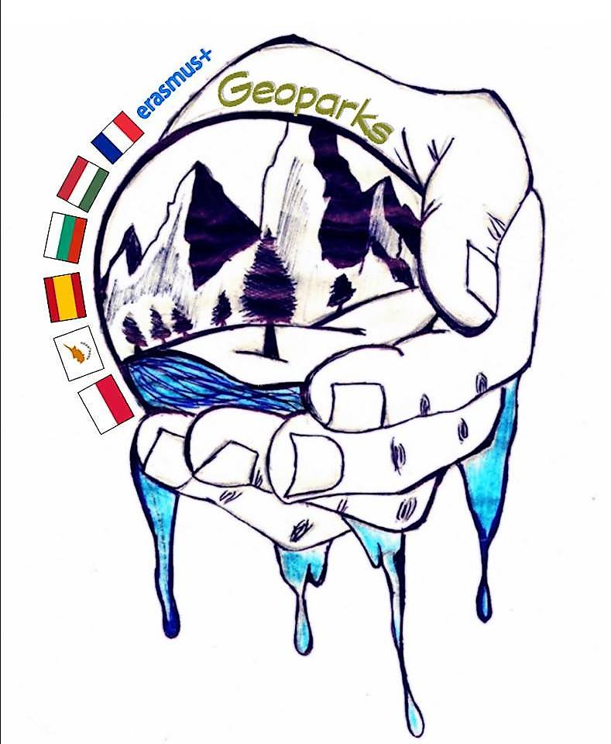

REPORT OF COORDINATOR

term 1 2018/2019

school name | Kaposvári Munkácsy Mihály Gimnázium
coordinator | Bálint Varga

number of teachers involved in project | 20
number of students involved in project | 15 + all atudents in the school (800; eg. exhibition) + all Hungarian students who went in for the geography competition (535; 1 task)

Project Event Details (according to mobility tool)

Please list and describe all project activities other international meeting for example: project management meetings, dissemination activities and other local activities and events in each school. The activities listed here will be included in the partnership final report as part of the project timetable.

Type of activity | start date | end date | short description
Project mamagement meetings | 12 Nov, 2018 | 13 Nov, 2018 | Evaluating the Cyprus trip witht the participating colleagues and students
Dissemination activity | 12 Nov, 2018 | 23 Nov, 2018 | The students who had taken part in the Cyprus meeting held presentations in different classes
Dissemination activity | 19 Nov, 2018 | 19 Nov, 2018 | Geo Day. Promoting geo-jobs in cooperation with the earth science and geography departments of the University of Pécs (https://pte.hu/english)
School event | 19 Nov, 2018 | 7 Dec, 2018 | Exibition displaying pictures of the Cyprus meeting and summer geo-photos of students
Evaluating meeting (project management) | 21 Nov, 2018 | 7 Dec, 2018 | Survey to teachers and students
Dissemination activity | 4 Feb, 2019 | 4 Feb, 2019 + published on the internet (can be accessed any time) | A task on (the participating) geoparks and countries included in the first round paper of the Lóczy Lajos National Geography Competition (http://loczyverseny.sulinet.hu/)
School event | 19 Nov, 2018 | 21 Dec, 2018 | Designing logos and voting for the best one
Project mamagement meetings |  | continuous | Preparing and organising the following meetings

