A photo exhibition titled " Land Reconstructions" by Agios Ioannis Lyceum, Cyprus.
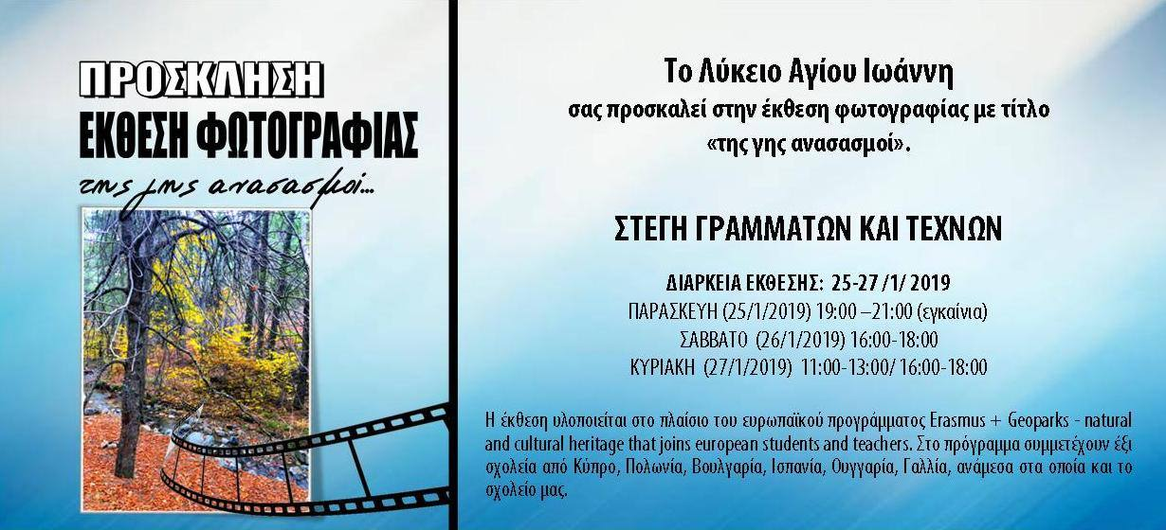
Agios Ioannis Lyceum in collaboration with the group of teachers and students of the Erasmus + program with title: “Geoparks - Natural and Cultural Heritage which joins European students and teachers”, organized a photography exhibition entitled "Land Reconstructions" from January 25th to January 27th, 2019, in an old preserved mansion in the center of Limassol, the “Home of Arts”. The exhibition was inaugurated on Friday 25 January at 19.00 by Dr. Androula Papanastasiou, Director of the Lifelong Learning Program Association (LLPA) of Cyprus, who is also the national coordinator for the Erasmus + School Partnerships program that our program belongs.
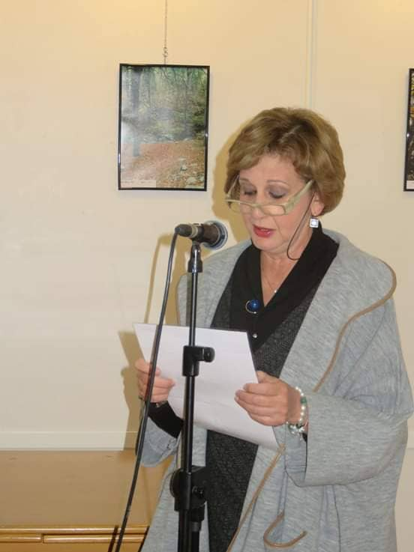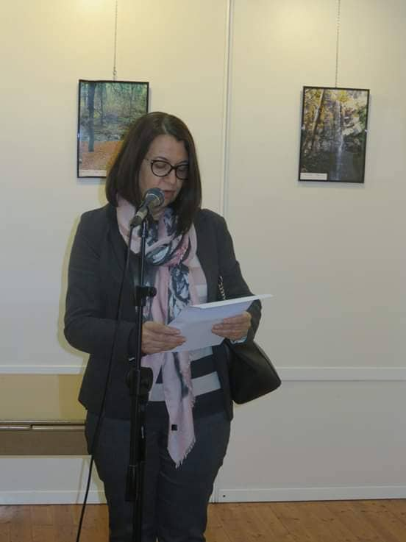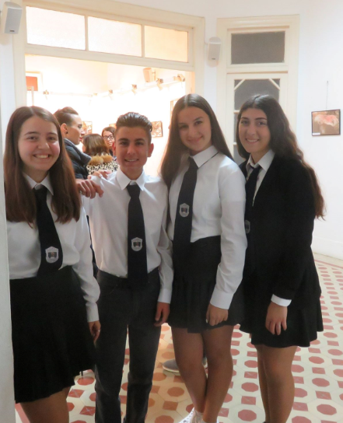
A greeting was also made by the Director of St. John's Lyceum Ms. Sylvia Oikonomidou which she noticed the meaning of photography art in the dissemination of the program. All photos belong to the students who took part in the first seminar of the program that took place in Cyprus. Their beauty and generally how they display Cyprus in a different perspective, but also how Troodos and the Troodos Geopark appear, was the reason for the program team to prepare this great success report and praiseworthy comments for all the photos. The program includes six schools from Cyprus, Poland, Bulgaria, Spain, Hungary, France, among them is also Agios Ioannis Lyceum.
