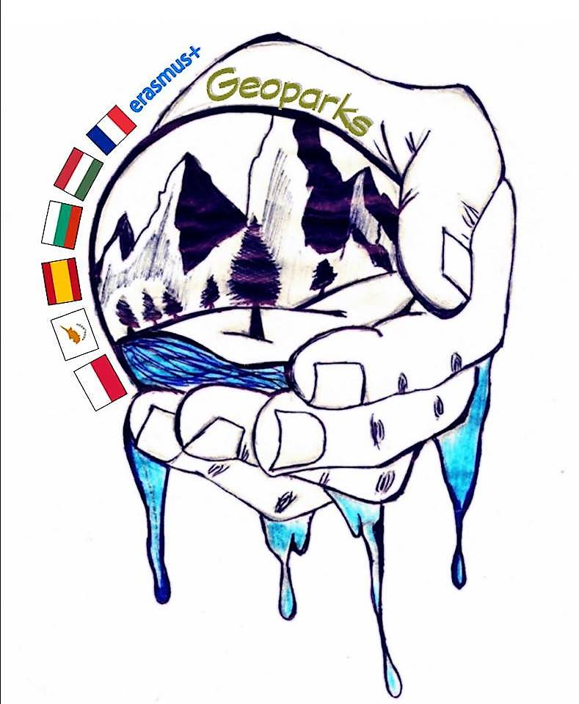

REPORT OF COORDINATOR

term 1 2018/2019

school name | Lykeio Agiou Ioanni, Limassol, Cyprus
coordinator | Nikolas Nikolaou

number of teachers involved in project | 6
number of students involved in project | 18

Project Event Details (according to mobility tool)

Please list and describe all project activities other international meeting for example: project management meetings, dissemination activities and other local activities and events in each school. The activities listed here will be included in the partnership final report as part of the project timetable.

Type of activity | start date | end date | short description
Project management meeting of Cyprus team | 01/09/2018 | 01/02/2019 | Meetings of team of Cyprus  Every 3 weeks team of Cyprus teachers and students had a meeting for the project and decide what to do for next steps about the project
Seminar for teachers and Students | 04/11/2018 | 08/11/2018 | Our school organised the first seminar for teachers and students in Cyprus (report in the webpage)
National Dissemination Activity | 01/10/2018 | ------------ | Webpage of the project in Schools Webpage  A webpage was created in the webpage of our school especially for our erasmus plus program. Link of the webpage http://lyk-ag-ioannis-lem.schools.ac.cy/index.php/eramus-main-menu-item/geoparks-menu/geoparks-info-menu
International Dissemination Activity | 12/11/2018 | ..................... | Poster of the 1st meeting in Cyprus  A poster was created from the students for disseminate our results. The poster will be shown in the 8th National Conference of Natural Sciences in Cyprus from 22 to 24 of February. The poster can be found in the webpage of the project and our school
International Dissemination Activity | 20/11/2018 | ................... | Video for the meeting in Youtube  Link of the video: https://www.youtube.com/watch?v=FGh9hbRlxLQ
School activity | 20/11/2018 | 13/12/2018 | Take a step forward: Our school organised an activity about discrimination so students to be able to accept all kind of students and characters (report in the webpage)
School Activity dissemination | 20/11/2018 | 15/12/2018 | Logo Contest in our school  A local logo contest among all the students of our school has been done so to be able to disseminate our program to the school and also to pick up the best 2 logos for International Logo Competition of our program  Report in the webpage - dissemination through creation in our school.
Local Activity | 22/11/2018 | 22/11/2018 | Methodology of educational research in collaboration with University of Nicosia  Lecture in the school about the connection of the research with Erasmus program Geoparks (report in the webpage)
Local Activity | 25/11/2018 | 25/11/2018 | Educational Trip to Troodos for 2 research teams of Agios Ioannis Lyceum (Geopark teams of students in research – report in the webpage)
National dissemination activity | 30/11/2018 | 2/12/2018 | Visit of Lyceum Agios Ioannis to the Exhibition ‘Memories of GAIA – UNESCO Global Geoparks of Greece and Cyprus in Athens (Greece)  Report in the webpage
National Dissemination activity | 01/12/2018 | 31/12/2019 | School Diary of Agios Ioannis Lyceum for 2019 including the photos of the students in Caledonia Trail in Troodos forest.  Report in the webpage – dissemination of the project through the beauties of Troodos Geopark and our diary.
School Disseemination Activity | 09/01/2019 | ................... | Erasmus Corner in our school  Report in the webpage the Erasmus corner will give latest news always of our program.
Dissemination activity | 18/01/2019 | 21/01/2019 | Posters of Sciences of Geopark of Trooodos  Groups of students made a lot of posters about biodiversity, Minerals and the Creation of Cyprus so these posters to be in our Erasmus corner to disseminate the results that can be found in Geopark of Troodos in these sciences. Posters can be found in the webpage of the project (3 posters)
School Local Activity | 18/01/2019 | 21/01/2019 | 3 days Educational Trip to Pedoulas in Troodos Geopark  Report that describe all activities about geology and biodiversity of the area can be found in webpage of the program and the webpage of the school.
National Dissemination Activity | 25/01/2019 | ------------- | Poster of 3 days educational trip in Troodos  The poster will be shown in National Conference of Sciences In Cyprus and can be found in our webpage
National Dissemination Activity | 25/01/2019 | 27/01/2019 | Photo Exhibition entitled “Earth Reconstraction”  Report in the webpage – dissemination of the project through the beauties of Troodos Geopark and our photo exhibition.
National Dissemination Activity | 01/11/2018 | .................. | Dissemination of activities of Agios Ioannis Lyceum to the Facebook page of Geopark of Troodos  Cooperation with the Geopark of Troodos through their Facebook webpage of activities that we do in school for the project. Cooperation will be continued through the whole 2 years project. Pages that can be found activities of our project are:  - https://www.facebook.com/troodosgeo/photos/a.605305449641378/1044963362342249/?type=3&theater  - https://www.facebook.com/troodosgeo/photos/a.605305449641378/1039629206208998/?type=3&theater  - https://www.facebook.com/troodosgeo/photos/a.605305449641378/1039629139542338/?type=3&theater  - https://www.facebook.com/troodosgeo/
Inernational Dissemination Activity | 01/02/2019 | ................... | Video of 3 days educational trip in Troodos  The video will be shown in National Conference of Sciences In Cyprus and can be found in our webpage
‘

